**INTRODUCTION**

Smart Health Assistance will be one stop single integrated Web Application to provide cure to all the basic medical problems. This Health Care Management application will be like in an online Healthcare Management service provider with easy-to-use customizable options.  It will be introduced with all modern diagnosing problems like Cough, fever, headache, allergies, throat pain, joint pain or any other disease factors.

It is used in the lifesaving equipment in case of emergency. It will do the same work for a Hospital as an ATM machine do for a Bank. Thus it will make easy to get basic medical problem for people where hospitals are not in easy reach and also provide a central platform for the patients to interact with the hospital staff in case of emergency.

Smart Health Assistance will be having many benefits over the present system as it will be an integrated machine that will provide solutions to all medical problems, requiring very small space for installation and working.

It will also help government hospitals such as AIIMS in providing their services to the people living in the different areas including rural India by installing their Smart Health Assistance countrywide so that people may excess the hospital information system from various remote locations.

* 1. **PROBLEM DEFINITION**

This is a project with objective to develop a basic Web Application where a patient provided with Eco Health care medical form to fill his information and login to his profile and get a cure medical guidance for which the medical problem he is suffering and also to know about the current technology used to develop the application. Our proposed project in real time will be maintained by compounder who will be guiding for rurals for operate and thus getting prescriptions. Accessing basic healthcare amenities is a real pain in rural India. One has to travel to a nearby town or city for even minor ailments and health assessments.

**OBJECTIVES**

Our main objective behind Smart Health Assistance is to make available a one stop solution to a patient for most of the medical problems and also to connect people with different hospitals in a better, modernize, simplified, easy and accurate way. Basic pillars of Eco Health care will be as follows: 1. Diagnostic equipment 2. Lifesaving equipment 3.Medicine Guider 4. Accurate curance for medical problem 5. Medicine stock and Emergency.

Eco medicine is the convergence of information technology (IT) and healthcare. Technological advancement evolved using Artificial Intelligence (AI), Internet of Things (IOT), Cloud computing, wireless & sensor network, electronic health records, hospital management information systems and tele-care services are best positioned to bring in cost-efficiency, reduce consultation time, improve accuracy of treatment to a large number of customers remotely and maintain high standards of service delivery by providing access to quality care on a real time basis. This project brings healthcare to any worksite, retail outlet or community centre. The goal of these compact, Eco Health is to deliver health care more quickly, conveniently, and cost effectively to patients. It covers all specialties from the remote location and gets specialist opinion.

Today the world’s most forward looking medical agency re trying to provide more reliable more accurate services in their field, offering services. It may be leading many different medical shops.

Smart health Assistance consists of multiple participants, such as doctors and patients, hospitals, and research institutions. It is an organic whole that involves multiple dimensions, including disease prevention and monitoring, diagnosis and treatment, hospital management, health decision-making, and medical research.

**GOALS OF THE PROPOSED SYSTEM**:

1. **Emergency Response**: We can respond to emergencies extremely quickly. When a devastating earthquake hit Haiti in 2010 our teams treated the first casualty within minutes.
2. **Access to Health Care**: Rapid emergency subsides people can find it difficult to access healthcare as the area struggles to recover, the government is overwhelmed by the scale of the problems. In these cases, MSF works to give people access to health care and to tackle diseases and provide medical subscription.
3. **Immediate storage records**: It helps to store the records of patient for future references and maintain the records of every patient without any loss of data.
4. **User friendly to operate**: Our proposed system will help every people including rurals to operate manually and easy transformation. And there will assigned a compounder who helps the patients to retrieve the curance of their risk.
5. **Accuracy**: The level of accurate in the proposed system will be accurate and thus the operations will be done correctly. The data will be highly secured and cannot be accessed without any identity.

### Disease prevention and risk monitoring:

### Traditional disease risk prediction is based on the initiative of the health authorities to collect patient information, compare that information with the guidelines of the authoritative organization, and finally release the prediction results. This method has a certain lag in time and does not provide accurate advice to individuals. Disease risk prediction under smart healthcare is dynamic and personalized. It enables patients and doctors to participate, proactively monitor their disease risk, and conduct targeted prevention based on their own monitoring results. Our smart health assistance have been classified the victims into 3 categories i.e. Infants, children’s, and adults. The patients who access the system will be able to get medicines based on their age priority and get a temporary cure.

**TOOLS/ENVIRONMENT USED**

In order to run this project, following is the configuration which is required for smooth running of the software.

**SOFTWARE REQUIRED**:

|  |  |
| --- | --- |
| Front End | PHP,HTML,CSS,BOOTSTRAP |
| Back End | XAMPP,SQL DATABASE |
| Operating system | Windows 10 |

**HARDWARE REQUIRED:**

|  |  |
| --- | --- |
| Processor | Pentium-IV Processor |
| RAM | 40GB or above |
| HDD | 256MB or above |

**PHP:**

Php is a popular general-purpose scripting language that is especially suited to web development. It was originally created by [Rasmus Lerdorf](https://en.wikipedia.org/wiki/Rasmus_Lerdorf) in 1994;[[6]](https://en.wikipedia.org/wiki/PHP#cite_note-History_of_PHP-6) the PHP [reference implementation](https://en.wikipedia.org/wiki/Reference_implementation) is now produced by The PHP Group. PHP originally stood for Personal Home Page,[[6]](https://en.wikipedia.org/wiki/PHP#cite_note-History_of_PHP-6) but it now stands for the [recursive initialise](https://en.wikipedia.org/wiki/Recursive_initialism) PHP: Hypertext Pre-processor.

PHP development began in 1994 when [Rasmus Lerdorf](https://en.wikipedia.org/wiki/Rasmus_Lerdorf) wrote several [Common Gateway Interface](https://en.wikipedia.org/wiki/Common_Gateway_Interface) (CGI) programs in C, which he used to maintain his [personal homepage](https://en.wikipedia.org/wiki/Personal_homepage). He extended them to work with [web forms](https://en.wikipedia.org/wiki/Web_form) and to communicate with [databases](https://en.wikipedia.org/wiki/Database), and called this implementation "Personal Home Page/Forms Interpreter" or PHP/FI. PHP is the most popular scripting language on the web. Without PHP Facebook, Yahoo, Google wouldn't have exist. The course is geared to make you a PHP pro. Once you digest all basics, the course will help you create your very own Opinion Poll application.

PHP can actually do anything related to server-side scripting or more popularly known as the backend of a website. For example, PHP can receive data from forms, generate dynamic page content, can work with databases, create sessions, send and receive cookies, send emails etc. There are also many hash functions available in PHP to encrypt user’s data that makes PHP secure and reliable to be used as a server-side scripting language. So these are some of the abilities of PHP that makes it suitable to be used as server-side scripting language.

**HTML:**

HTML stands for Hyper Text Mark-up Language. It is used to design web pages using mark-up language. HTML is the combination of Hypertext and Markup language. Hypertext defines the link between the web pages. Mark-up language is used to define the text document within tag which defines the structure of web pages.

HTML is a mark-up language which is used by the browser to manipulate text, images and other content to display it in required format. [HTML elements](https://en.wikipedia.org/wiki/HTML_element) are the building blocks of HTML pages. With HTML constructs, [images](https://en.wikipedia.org/wiki/HTML_element#Images_and_objects) and other objects such as [interactive forms](https://en.wikipedia.org/wiki/Fieldset) may be embedded into the rendered page. HTML provides a means to create [structured documents](https://en.wikipedia.org/wiki/Structured_document) by denoting structural [semantics](https://en.wikipedia.org/wiki/Semantics) for text such as headings, paragraphs, lists, [links](https://en.wikipedia.org/wiki/Hyperlink), quotes and other items. HTML elements are delineated by tags, written using [angle brackets](https://en.wikipedia.org/wiki/Bracket#Angle_brackets). Tags such as <img /> and <input /> directly introduce content into the page. Other tags such as <p> surround and provide information about document text and may include other tags as sub-elements. Browsers do not display the HTML tags, but use them to interpret the content of the page.

**CSS:**

**C**ascading **S**tyle **S**heets, fondly referred to as **CSS**, is a simply designed language intended to simplify the process of making web pages presentable. CSS allows you to apply styles to web pages. More importantly, CSS enables you to do this independent of the HTML that makes up each web page. A CSS comprises of style rules that are interpreted by the browser and then applied to the corresponding elements in your document.

CSS is designed to enable the separation of presentation and content, including [layout](https://en.wikipedia.org/wiki/Page_layout), [colors](https://en.wikipedia.org/wiki/Color" \o "Color), and [fonts](https://en.wikipedia.org/wiki/Typeface). This separation can improve content [accessibility](https://en.wikipedia.org/wiki/Accessibility) and provide more flexibility and control in the specification of presentation characteristics, enable multiple [web pages](https://en.wikipedia.org/wiki/Web_page) to share formatting by specifying the relevant CSS in a separate .css file, and reduce complexity and repetition in the structural content.

CSS handles the look and feel part of a web page. Using CSS, you can control the color of the text, the style of fonts, the spacing between paragraphs, how columns are sized and laid out, what background images or colors are used, layout designs, and variations in display for different devices and screen sizes as well as a variety of other effects.

**BOOTSTRAP:**

Bootstrap is a [free and open-source](https://en.wikipedia.org/wiki/Free_and_open-source) [CSS framework](https://en.wikipedia.org/wiki/CSS_framework) directed at responsive, [mobile-first](https://en.wikipedia.org/wiki/Responsive_web_design#Mobile_first,_unobtrusive_JavaScript,_and_progressive_enhancement) [front-end web development](https://en.wikipedia.org/wiki/Front-end_web_development). It contains [CSS](https://en.wikipedia.org/wiki/CSS)- and (optionally) [JavaScript](https://en.wikipedia.org/wiki/JavaScript)-based design templates for [typography](https://en.wikipedia.org/wiki/Web_design#Typography), [forms](https://en.wikipedia.org/wiki/Form_(HTML)), [buttons](https://en.wikipedia.org/wiki/Button_(computing)#HTML), [navigation](https://en.wikipedia.org/wiki/Web_navigation#Local_website_navigation), and other interface components. Bootstrap, originally named Twitter Blueprint, was developed by Mark Otto and Jacob Thornton at [Twitter](https://en.wikipedia.org/wiki/Twitter) as a framework to encourage consistency across internal tools. Before Bootstrap, various libraries were used for interface development, which led to inconsistencies and a high maintenance burden.

Nowadays, the websites are perfect for all the browsers (IE, Firefox and Chrome) and for all sizes of screens (Desktop, Tablets, Phablets, and Phones). All thanks to Bootstrap developers -Mark Otto and Jacob Thornton of Twitter, though it was later declared to be an open-source project.  It solves many problems which we had once, one of which is the cross-browser compatibility issue.

**XAMPP:**

Xampp is a [free and open-source](https://en.wikipedia.org/wiki/Free_and_open-source) [cross-platform](https://en.wikipedia.org/wiki/Cross-platform) [web server](https://en.wikipedia.org/wiki/Web_server) [solution stack](https://en.wikipedia.org/wiki/Solution_stack) package developed by Apache Friends,consisting mainly of the [Apache HTTP Server](https://en.wikipedia.org/wiki/Apache_HTTP_Server), [Maria DB](https://en.wikipedia.org/wiki/MariaDB) [database](https://en.wikipedia.org/wiki/Database), and [interpreters](https://en.wikipedia.org/wiki/Interpreter_(computing)) for scripts written in the [PHP](https://en.wikipedia.org/wiki/PHP) and [Perl](https://en.wikipedia.org/wiki/Perl) [programming languages](https://en.wikipedia.org/wiki/Programming_language).Since most actual web server deployments use the same components as XAMPP, it makes transitioning from a local test server to a live server possible. XAMPP is regularly updated to the latest releases of [Apache](https://en.wikipedia.org/wiki/Apache_HTTP_Server), [Maria DB](https://en.wikipedia.org/wiki/MariaDB), [PHP](https://en.wikipedia.org/wiki/PHP) and [Perl](https://en.wikipedia.org/wiki/Perl). It also comes with a number of other modules including [OpenSSL](https://en.wikipedia.org/wiki/OpenSSL).

**DATABASE DESIGN**

**REGISTRATION**

|  |  |
| --- | --- |
| **FIELD** | **TYPE** |
| fullname | varchar(50) |
| phone | varchar(20) |
| emailid | varchar(50) |
| dateofbirth | varchar(15) |
| gender | varchar(10) |
| age | int(10) |
| regno | int(10) |
| password | varchar(50) |
| address | varchar(100) |

Table structure for table `regn`

--

CREATE TABLE IF NOT EXISTS `regn` (

`fullname` varchar(50) NOT NULL,

`phone` varchar(20) NOT NULL,

`emailid` varchar(50) NOT NULL,

`dateofbirth` varchar(15) NOT NULL,

`gender` varchar(10) NOT NULL,

`age` int(5) NOT NULL,

`regno` int(5) NOT NULL,

`password` varchar(50) NOT NULL,

`address` varchar(100) NOT NULL

) ENGINE=InnoDB DEFAULT CHARSET=utf8mb4;

--

-- Dumping data for table `regn`

--

INSERT INTO `regn` (`fullname`, `phone`, `emailid`, `dateofbirth`, `gender`, `age`, `regno`, `password`, `address`) VALUES

('chandan cn', '9900605079', 'chandangowda.cn@gmail.com', '2018-08-10', 'Male', 2, 1, '1234', 'ittamadu'),

('chadnu', '8660901237', 'dfhg@gmail.com', '2002-04-10', 'Male', 18, 2, '1234', 'bangalore'),

('chandu', '21243423', 'csadfsdfsdf@gmail.com', '1999-03-12', 'Male', 21, 4, '123', 'ds'),

(‘prajwal’,90035566’,’pwajwal@gmail.com’,’2000-04-09’,’Male’,’19’,’5’,’1234’,’garden’);

**RECORDS**

|  |  |
| --- | --- |
| **FIELD** | **TYPE** |
| date | varchar(15) |
| regno | varchar(50) |
| maincat | varchar(50) |
| subcat | varchar(50) |
| symptom | varchar(50) |
| medicine | varchar(100) |

Table structure for table `records`

--

CREATE TABLE IF NOT EXISTS `records` (

`date` varchar(15) NOT NULL,

`regno` varchar(50) NOT NULL,

`maincat` varchar(50) NOT NULL,

`subcat` varchar(50) NOT NULL,

`symptom` varchar(50) NOT NULL,

`medicine` varchar(100) NOT NULL

) ENGINE=InnoDB DEFAULT CHARSET=utf8mb4;

--

-- Dumping data for table `records`

--

INSERT INTO `records` (`date`, `regno`, `maincat`, `subcat`, `symptom`, `medicine`) VALUES

('2020-01-17', '6', 'Pains', 'Fracture', 'RAsh', 'Dolo'),

('2020-01-18', '7', 'Allergies', 'ENT', 'Sneez', 'Dolo 700'),

('2020-01-18', '8', 'Monsoon', 'Cough', 'SourThroat', '500mg'),

('2020-02-21', '2', 'Throat', 'Throat_Ulcer', 'irritation', 'Anti _Anginal_medicine'),

('2020-02-21', '2', 'Allergies', 'skin', 'itching', 'Hydrocortisone_cream'),

('2020-02-26', '1', 'Allergies', 'skin', 'itching', 'Hydrocortisone_cream'),

('2020-02-27', '3', 'Throat', 'Fever', 'Chills,Body_aches', 'Paracetamol');

('2020-02-27', '3', 'Throat', 'Fever', 'Chills,Body_aches', 'Paracetamol'),

('2020-02-25', '1', 'Throat', 'Throat_Ulcer', 'Irritation', 'Vocal_Theraphy');

**MEDICINE**

|  |  |
| --- | --- |
| **FIELD** | **TYPE** |
| main cat | varchar(50) |
| sub cat | varchar(50) |
| symptom | varchar(50) |
| category | varchar(50) |

Table structure for table `medicine`

--

CREATE TABLE `medicine` (

`maincat` varchar(50) NOT NULL,

`subcat` varchar(50) NOT NULL,

`symptom` varchar(50) NOT NULL,

`category` varchar(50) NOT NULL,

`medicine` varchar(100) NOT NULL

) ENGINE=InnoDB DEFAULT CHARSET=utf8mb4;

--

-- Dumping data for table `medicine`

--

INSERT INTO `medicine` (`maincat`, `subcat`, `symptom`, `category`, `medicine`) VALUES

('THROAT', 'Fever', 'with_chills', 'Infant', 'paracetamol drops'),

('THROAT', 'Fever', 'with_body_aches', 'Infant', 'paracetamol drops'),

('THROAT', 'Cough', 'with_Spuntum', 'Infant', 'Sp_Piriton_drops'),

('MONSOON', 'Fever', 'Headache', 'Infant', 'Tab_dolo_drops'),

('MONSOON', 'Fever', 'Bodyache', 'Infant', 'Tab_Inac_drops'),

('PAINS', 'joint_pain', 'with_fever', 'Infant', 'Inac_drops'),

('HEART', 'With_sweating', 'wet_palms_of_the_hands', 'Children', 'clopilet_syrup');

('ALLERGIES', 'skin', 'itching', 'Infant', 'paracetamol_syrup'),

('INJURIES', 'Swelling', 'Along_bones', 'Infant', 'Inac_drops'),

('THROAT', 'Earache', 'with_discharge', 'Infant', 'Tab_novomox_drops');

**PROGRAM CODE**

**WELCOME**

<!DOCTYPE html>

<html lang="en">

<head>

<meta charset="UTF-8">

<meta name="viewport" content="width=device-width, initial-scale=1.0">

<meta http-equiv="X-UA-Compatible" content="ie=edge">

<linkrel="stylesheet"href="https://stackpath.bootstrapcdn.com/bootstrap/4.4.1/css/bootstrap.min.css"

integrity="sha384Vkoo8x4CGsO3+Hhxv8T/Q5PaXtkKtu6ug5TOeNV6gBiFeWPGFN9MuhOf23Q9Ifjh" crossorigin="anonymous">

<script src="https://code.jquery.com/jquery-3.4.1.slim.min.js"

integrity="sha384J6qa4849blE2+poT4WnyKhv5vZF5SrPo0iEjwBvKU7imGFAV0wwj1yYfoRSJoZ+n"

crossorigin="anonymous"></script>

<script src="https://cdn.jsdelivr.net/npm/popper.js@1.16.0/dist/umd/popper.min.js"

integrity="sha384Q6E9RHvbIyZFJoft+2mJbHaEWldlvI9IOYy5n3zV9zzTtmI3UksdQRVvoxMfooAo"

crossorigin="anonymous"></script>

<script src="https://stackpath.bootstrapcdn.com/bootstrap/4.4.1/js/bootstrap.min.js"

integrity="sha384wfSDF2E50Y2D1uUdj0O3uMBJnjuUD4Ih7YwaYd1iqfktj0Uod8GCExl3Og8ifwB6"

crossorigin="anonymous"></script>

<title>Document</title>

<script type = "text/javascript">

function foo(){

alert("hi")

}

</script>

<style>

body, html {

height: 100%;

}

.bg {

/* The image used */

background-image: url("images/welcome1.jpg");

/* Full height */

height: 100%;

/* Center and scale the image nicely */

background-position: center;

background-repeat: no-repeat;

background-size: cover;

}

div.a {

text-align: center;

}

</style>

</head>

<body class="bg1">

<nav class="navbar navbar-expand-lg navbar-light bg-light">

<a class="nav-link" href="ambulance.php"><img src= "images/a1.Jfif" width="100" height="70"></img></a> <span class="sr-only">(current)</span></a>

<a class="nav-link" href="#" style = "color:DodgerBlue;"><h2><font face="Rockwell">SmartHealth Assistance</h2>

</h2>

<button class="navbar-toggler" type="button" data-toggle="collapse" data-target="#navbarSupportedContent-555"

aria-controls="navbarSupportedContent-555" aria-expanded="false" aria-label="Toggle navigation">

<span class="navbar-toggler-icon"></span>

</button>

<div class="collapse navbar-collapse" id="navbarSupportedContent-555">

<ul class="navbar-nav mr-auto">

<li class="nav-item active">

</a></li>

<li class="nav-item ">

<a class="nav-link" href="login.php" ><h5><b>Login</b></h5></a></li>

<li class="nav-item">

<a class="nav-link" href="registration.php"><h5><b>Registration</b></h5></a> </li>

<li class="nav-item">

<a class="nav-link" href="test.php"><h5><b>Stock</b></h5></a> </li>

<li class="nav-item">

<a class="nav-link" href="getpres.php"><h5><b>Records</b></h5></a></li>

<li class="nav-item">

<a class="nav-link" href="srch.php"><h5><b>Search</b></h5></a></li>

<li class="nav-item">

<a class="nav-link" href="medrecords.php"><h5><b>Medicines</b></h5></a>

<li class="nav-item">

<a class="nav-link" href="about.html"><h5><b>About</b></h5></a></li></ul>

</div >

</font>

<ul class="navbar-nav ml-auto nav-flex-icons">

<li class="nav-item avatar">

<a class="nav-link p-0" href="#">

<img src="images/st.jpg" class="rounded-circle z-depth-0"

alt="avatar image" height="80" width="80">

</a></li></ul></nav>

<div id="carouselExampleSlidesOnly" class="carousel slide" data-ride="carousel">

<div class="carousel-inner">

<div class="carousel-item active">

<img src="images/2.jpg" class="d-block w-100" alt="..."></div>

<div class="carousel-item">

<img src="images/new1.jpg" class="d-block w-100" alt="..."></div>

<div class="carousel-item">

<img src="images/welcome.jpg" class="d-block w-100 h-80" alt="..."></div></div></div>

<form method="POST" >

<div class="a"><h4><font face="Bahnschrift SemiCondensed" size="20" align="center" color="Dodgerblue"><h2><b>Perceverance Excellance Service</b></h2>

</font></div>

</body>

</html>

**LOGIN**

<?php

session_start();

?>

<!DOCTYPE html>

<html lang="en">

<head>

<meta charset="UTF-8">

<meta name="viewport" content="width=device-width, initial-scale=1.0">

<meta http-equiv="X-UA-Compatible" content="ie=edge">

<linkrel="stylesheet"href="https://stackpath.bootstrapcdn.com/bootstrap/4.4.1/css/bootstrap.min.css"

integrity="sha384Vkoo8x4CGsO3+Hhxv8T/Q5PaXtkKtu6ug5TOeNV6gBiFeWPGFN9MuhOf23Q9Ifjh" crossorigin="anonymous">

<title>Doctor's A T M</title>

<style>

body, html {

height: 100%;

}

.bg {

/* The image used */

background-image: url("images/login.jpg");

/* Full height */

height: 100%;

/* Center and scale the image nicely */

background-position: center;

background-repeat: no-repeat;

background-size: cover;

}

input[type=number]:focus {

background-color: LightYellow;

}

</style>

</head>

<body class="bg">

<nav class="navbar navbar-expand-lg navbar-light bg-light">

<a class="nav-link" href="ambulance.php"><img src= "images/a1.Jfif" width="100" height="70"></img></a> <span class="sr-only">(current)</span></a>

<a class="navbar-brand" href="#" style = "color:Dodgerblue;"> <h2><font face="Rockwell">SmartHealth Assistance</h2></a></font>

<ul class="navbar-nav ml-auto nav-flex-icons">

<li class="nav-item avatar">

<a class="nav-link p-0" href="#">

<img src="images/st.jpg" class="rounded-circle z-depth-0"

alt="avatar image" height="80" width="80">

</a>

</li>

</ul>

</nav>

<?php

if(isset($_POST['login'])){

$servername = "localhost";

$username = "root";

$password = "";

$dbname = "doctoratm";

$conn = new mysqli($servername, $username, $password, $dbname);

$regnno = $_POST['RegnNo'];

$pwd = $_POST['Password'];

$sql = 'SELECT * FROM regn where regno ='.$regnno;

$result = $conn->query($sql);

$row = $result->fetch_assoc() ;

if($row['regno'] != (int)$regnno || $row['password'] != $pwd){

echo '<h2><i>Regn Number or password entered in incorrect!!</i></h2>';

}

else

{

echo '<h2>Login Successfull....</h2>';

if ((int) $row['regnno'] <= 10){

// header("refresh:3;url=select.php" );

$_SESSION['regnno'] = (int) $row['regno'];

$_SESSION['age'] = $row['age'];

header("Location:select.php");

}

}

}

?>

<form method="POST" >

<div class="container" style="margin-top: 50px;">

<div><h3 style="color:purple" ><font face="Bahnschrift" size="6"><u>Login</u></h3></div></font>

<div class="form-row">

<div class="form-group col-md-4">

<label for="inputEmail4" style="color:blue"><font face="Rockwell" size="4">Enter your Registration number</label></font>

<input type="number" class="form-control" name="RegnNo" placeholder="Enter Reg no" required autofocus></div>

<div class="form-group col-md-4" style="color:blue" >

<label for="inputPassword4"><font face="Rockwell" size="4">Enter your password</label>

<input type="password" class="form-control" name="Password" require</div></div><div class="form-row">

<div class="form-group col-md-4">

<button type="submit" class="btn btn-primary" name = "login"> Login</button>

<button type="submit" class="btn btn-warning" onClick="document.location.href='welcome.html';" >Home</button>

<button type = "reset" class="btn btn-danger" name = "reset">Clear</button><br><br><br>

<div style="background-color:white">

<a href="otp.php"><b>Forgot password...</a> <br>

<a href="Registration.php" style="color:grey" > Click here for New User</a>

</div></div></div> </form></div>

</body>

</html>

**REGISTRATION**

<!DOCTYPE html>

<html lang="en">

<head>

<meta charset="UTF-8">

<meta name="viewport" content="width=device-width, initial-scale=1.0">

<meta http-equiv="X-UA-Compatible" content="ie=edge">

<linkrel="stylesheet"href="https://stackpath.bootstrapcdn.com/bootstrap/4.4.1/css/bootstrap.min.css"

integrity="sha384Vkoo8x4CGsO3+Hhxv8T/Q5PaXtkKtu6ug5TOeNV6gBiFeWPGFN9MuhOf23Q9Ifjh" crossorigin="anonymous">

<title>Doctor's A T M</title><style>

body, html {

height: 50%;

}

.bg {

/* The image used */

background-image: url("images/register.jpg");

/* Full height */

height: 100%;

/* Center and scale the image nicely */

background-position:;

background-repeat: no-repeat;

background-size: cover;

}

input[type=text]:focus {

background-color: LightYellow;

}

</style>

</head>

<body class="bg">

<nav class="navbar navbar-expand-lg navbar-light bg-light">

<a class="nav-link" href="ambulance.php"><img src= "images/a1.Jfif" width="100" height="70"></img></a> <span class="sr-only">(current)</span></a>

<a class="navbar-brand" href="#" style = "color:Dodgerblue;"> <h3><font face="Rockwell">SmartHealth Assistance</h3></a></font>

<ul class="navbar-nav ml-auto nav-flex-icons">

<li class="nav-item avatar">

<a class="nav-link p-0" href="#">

<img src="images/st.jpg" class="rounded-circle z-depth-0"

alt="avatar image" height="80" width="80"></a></li></ul></nav>

<?php

if(isset($_POST['signup'])){

$servername = "localhost";

$username = "root";

$password = "";

$dbname = "doctoratm";

// Create connection

$conn = new mysqli($servername, $username, $password, $dbname);

$fullname = $_POST['FullName'];

$mobilenumber = $_POST['MobileNumber'];

$address = $_POST['Address'];

$emailid = $_POST['EmailId'];

$dateofbirth = $_POST['DateOfBirth'];

$gender = $_POST['Gender'];

$age = date('Y') - (int) substr($dateofbirth,0,4);

$pwd = $_POST['Password'];

$regnno = 1;

$sql = "SELECT max(regno) as 'm' FROM regn";

$result = $conn->query($sql);

while($row = $result->fetch_assoc()) {

$regnno = $row['m'] + 1;

}

$sql = "INSERT INTO REGN VALUES('$fullname', '$mobilenumber', '$emailid', '$dateofbirth', '$gender', $age, $regnno,'$pwd', '$address')";

if($conn->query($sql) === TRUE)

{

echo '<h3>'.'Your record has been saved successfully'.'</h3><br>';

echo '<h3>'.'Please note your registration number is : '.$regnno.'</h3>';

header("refresh:3;url=welcome.html" );

}

else{

echo 'Failed';

}

$conn->close();

}

?>

<form method="POST">

<div class="container" style="margin-top: 50px; margin-left:80px;"><font face="Rockwell" size="3">

<div><h1><u><font face="Bahnschrift SemiCondensed">New Patient Sign Up</font></u></h1></div>

<div class="form-row">

<div class="form-group col-md-4">

<label for="inputEmail4"><b>Full Name</b></label>

<input type="text" class="form-control" name="FullName" placeholder="fullname" required autofocus></div>

<div class="form-group col-md-4">

<label for="inputPassword4"><b>Mobile Number</b><sup>*</sup></label>

<input type="number" class="form-control" name="MobileNumber" required>

</div></div>

<div class="form-row">

<div class="form-group col-md-4"><label for="inputEmail4"><b>Address</b></label>

<input type="text" class="form-control" name="Address" placeholder="Address" required></div>

<div class="form-group col-md-4">

<label for="inputPassword4"><b>Email ID</b><sup>*</sup></label>

<input type="email" class="form-control" name="EmailId"></div></div>

<div class="form-row"><div class="form-group col-md-4">

<label for="inputEmail4"><b>Date of birth</b><sup>*</sup></label>

<input type="date" class="form-control" name="DateOfBirth" required></div>

<div class="form-group col-md-4">

<label for="inputPassword4"><b>Gender</b></label> <br>

<select name="Gender" name="Gender" class="form-control" required>

<option value="">

Select

</option>

<option value="Male">

Male

</option>

<option value="Female">

Female

</option>

<option value="Other">

Other

</option>

</select></div></div>

<div class="form-row">

<div class="form-group col-md-4">

<label for="inputEmail4"><b>Login Password</b></label> <br>

<label for="inputEmail4"><b>Enter password</b></label>

<input type="password" class="form-control" name="Password" required></div></div>

<div class="form-row">

<div class="form-group col-md-4"><button type="submit" class="btn btn-success" name = "signup" > Sign up</button>

</body>

</html>

**MEDICINE ENTRY**

<!DOCTYPE html>

<html lang="en">

<head>

<meta charset="UTF-8">

<meta name="viewport" content="width=device-width, initial-scale=1.0">

<meta http-equiv="X-UA-Compatible" content="ie=edge">

<link rel="stylesheet" href="https://stackpath.bootstrapcdn.com/bootstrap/4.4.1/css/bootstrap.min.css"

integrity="sha384Vkoo8x4CGsO3+Hhxv8T/Q5PaXtkKtu6ug5TOeNV6gBiFeWPGFN9MuhOf23Q9Ifjh" crossorigin="anonymous"

<title>Doctor's A T M</title><style>

body, html {

height: 50%;

}

.bg {

/* The image used */

background-image: url("images/inventory.jpg");

/* Full height */

height: 100%;

/* Center and scale the image nicely */

background-position:;

background-repeat: no-repeat;

background-size: cover;

}</style>

< /head>

<body class="bg">

<nav class="navbar navbar-expand-lg navbar-light bg-light">

<a class="nav-link" href="ambulance.php"><img src= "images/a1.Jfif" width="100" height="70"></img></a> <span class="sr-only">(current)</span></a>

<a class="navbar-brand" href="#" style = "color: blue;"> <h2><font face="Rockwell">SmartHealth Assistance</h2></a></font>

<ul class="navbar-nav ml-auto nav-flex-icons">

<li class="nav-item avatar">

<a class="nav-link p-0" href="#">

<img src="images/st.jpg" class="rounded-circle z-depth-0"

alt="avatar image" height="80" width="80"></a></li></ul></nav>

<?php

if(isset($_POST['signup'])){$servername = "localhost";

$username = "root";

$password = "";

$dbname = "doctoratm";

// Create connection

$conn = new mysqli($servername, $username, $password, $dbname);

$mc = $_POST['maincat'];

$sc = $_POST['subcat'];

$sy = $_POST['symptom'];

$med = $_POST['medicine'];

$cat = $_POST['category'];

$sql = "INSERT INTO MEDICINE VALUES('$mc', '$sc', '$sy', '$cat', '$med')";

if($conn->query($sql) === TRUE){

echo '<h4>'.'Your record has been saved successfully'.'</h4><br>';else

echo 'Failed';

}

$conn->close();

}

?>

<form method="POST">

<div class="container" style="margin-top:100px;" ><font face="Rockwell" color="black">

<div><h1><b>Medicine Data Entry Screen</b></h1></div><br></font>

<div class="form-row">

<div class="form-group col-md-4">

<label for="inputEmail4"><h5><font face="Rockwell">Select Category</h5></label></font>

<select name="category" name="category" class="form-control" required>

<option value="" >

Select

</option>

<option value="Infant">

Infant ( Less than 5 Years)

</option>

<option value="Children">

Children ( From 5 to 19 Years)

</option>

<option value="Adult">

Adult ( Above 19 Years)

</option></select></div>

<div class="form-group col-md-4">

<label for="inputPassword4"><h5><font face="Rockwell">Main category of illness or disease</h5></label>

<select name="maincat" name="maincat" class="form-control" required>

<option value="" >

Select</option>

<option value="ALLERGIES">

ALLERGIES

</option>

<option value="MONSOON">

MONSOON

</option>

<option value="INJURIES">

INJURIES

</option>

<option value="HEART">

HEART

</option>

<option value="PAINS">

PAINS

</option>

<option value="THROAT">

THROAT </option>

</select></div></div>

<div class="form-row">

<div class="form-group col-md-4">

<label for="inputEmail4"><h5>Sub category</h5></label>

<input type="text" class="form-control" name="subcat" required></div>

<div class="form-group col-md-4">

<label for="inputPassword4"><h5>Symptom</h5></label>

<input type="text" class="form-control" name="symptom" required></div></div>

<div class="form-row">

<div class="form-group col-md-4">

<label for="inputEmail4"><h5>Medicine</h5></label>

<input type="text" class="form-control" name="medicine" required></div></div>

<div class="form-row">

<div class="form-group col-md-4">

<button type="submit" class="btn btn-primary" name = "signup" > SAVE</button>

<button type="submit" class="btn btn-warning" onClick="document.location.href='welcome.html';" >Home</button>

<button type = "reset" class="btn btn-danger" name = "reset">Reset</button></div></div></div></form></div></font>

</body>

</html>

**MAIN CATEGORY**

<!DOCTYPE html>

<html lang="en">

<head>

<meta charset="UTF-8">

<meta name="viewport" content="width=device-width, initial-scale=1.0">

<meta http-equiv="X-UA-Compatible" content="ie=edge">

<link rel="stylesheet" href="https://stackpath.bootstrapcdn.com/bootstrap/4.4.1/css/bootstrap.min.css"

integrity="sha384Vkoo8x4CGsO3+Hhxv8T/Q5PaXtkKtu6ug5TOeNV6gBiFeWPGFN9MuhOf23Q9Ifjh" crossorigin="anonymous">

<link rel="stylesheet" href="https://www.w3schools.com/w3css/4/w3.css">

<title>Doctor's A T M</title>

<style>

body, html {

height: 100%; }

.bg {

/* The image used */

background-image: url("images/select.jpg");

/* Full height */

height: 100%;

/* Center and scale the image nicely */

background-position: center;

background-repeat: no-repeat;

background-size: cover;

}</style></head>

<body class="bg">

<nav class="navbar navbar-expand-lg navbar-light bg-light">

<a class="nav-link" href="ambulance.php"><img src= "images/a1.Jfif" width="100" height="70"></img></a> <span class="sr-only">(current)</span></a>

<a class="navbar-brand" href="#" style = "color: Dodgerblue;"><font face="Rockwell"><h2>SmartHealth Assistance</font></h2></a>

<ul class="navbar-nav ml-auto nav-flex-icons">

<li class="nav-item avatar">

<a class="nav-link p-0" href="#">

<img src="images/st.jpg" class="rounded-circle z-depth-0"

alt="avatar image" height="80" width="80"></img></a></li></ul></nav>

<?php

session_start();

?>

<form method = "post">

<div class="w3-container" style="margin-top: 70px; margin-left:90px;">

<div class="row">

<div class="w3-display-container w3-hover-opacity" style="width:30%">

<img src="images/throat1.jpg" alt="Avatar" width = "400px" height="220px">

<div class="w3-display-middle w3-display-hover w3-xxlarge">

<button class="w3-button w3-aqua" name="1">ThroatPain</button></div></div>

<div class="w3-display-container w3-hover-opacity" style="width:30%">

<img src="images/allergies1.jpg" alt="Avatar" width = "400px" height="220px">

<div class="w3-display-middle w3-display-hover w3-xxlarge">

<button class="w3-button w3-purple" name="2">Allergies</button></div></div>

<div class="w3-display-container w3-hover-opacity" style="width:30%">

<img src="images/monsoon.png" alt="Avatar" width = "400px" height="220px">

<div class="w3-display-middle w3-display-hover w3-xxlarge">

<button class="w3-button w3-orange" name="3">Mansoon</button</div></div></div><div class="row">

<div class="w3-display-container w3-hover-opacity" style="width:30%">

<img src="images/Injuries.jpg" alt="Avatar" width = "400px" height="220px">

<div class="w3-display-middle w3-display-hover w3-xxlarge">

<button class="w3-button w3-yellow" name="4" >Injuries</button></div></div>

<div class="w3-display-container w3-hover-opacity" style="width:30%">

<img src="images/heart2.jpg" alt="Avatar" width = "400px" height="220px">

<div class="w3-display-middle w3-display-hover w3-xxlarge">

<button class="w3-button w3-red" name="5" >Heart</button></div></div>

<div class="w3-display-container w3-hover-opacity" style="width:30%">

<img src="images/pains.jpg" alt="Avatar" width = "400px" height="220px">

<div class="w3-display-middle w3-display-hover w3-xxlarge">

<button class="w3-button w3-blue" name="6">Pains</button></div></div></div></div>

<div class="row" style="margin-left:90px;"><div >

<button class = "btn btn-warning" name= "cancel" >Home</button></div></div> </form>

<?php

if(isset($_POST['cancel'])){

header("Location:welcome.html");

}

if(isset($_POST['1'])){

$_SESSION['maincat'] = "Throat";

header("Location:select2.php");

}

if(isset($_POST['2'])){

$_SESSION['maincat'] = "Allergies";

header("Location:select2.php");

}

if(isset($_POST['3'])){

$_SESSION['maincat'] = "Monsoon";

header("Location:select2.php");

}

if(isset($_POST['4'])){

$_SESSION['maincat'] = "Injuries";

header("Location:select2.php");

}

if(isset($_POST['5'])){

$_SESSION['maincat'] = "Heart";

header("Location:select2.php");

}

if(isset($_POST['6'])){

$_SESSION['maincat'] = "Pains";

header("Location:select2.php");

}

?>

</body></html>

**SUB-CATEGORY**

<!DOCTYPE html>

<html lang="en">

<head>

<meta charset="UTF-8">

<meta name="viewport" content="width=device-width, initial-scale=1.0">

<meta http-equiv="X-UA-Compatible" content="ie=edge">

<linkrel="stylesheet"href="https://stackpath.bootstrapcdn.com/bootstrap/4.4.1/css/bootstrap.min.css"

integrity="sha384Vkoo8x4CGsO3+Hhxv8T/Q5PaXtkKtu6ug5TOeNV6gBiFeWPGFN9MuhOf23Q9Ifjh" crossorigin="anonymous">

<title>Doctor's A T M</title>

<style>

body, html {

height: 100%;

}

.bg {

/* The image used */

background-image: url("images/subcat1.jpg");

/* Full height */

height: 100%;

/* Center and scale the image nicely */

background-position: center;

background-repeat: no-repeat;

background-size: cover;

}

</style>

</head>

<body class="bg">

<nav class="navbar navbar-expand-lg navbar-light bg-light">

<a class="nav-link" href="ambulance.php"><img src= "images/a1.Jfif" width="100" height="70"></img></a> <span class="sr-only">(current)</span></a>

<a class="navbar-brand" href="#" style = "color: Dodgerblue;"> <h3><font face="Rockwell">SmartHealth Assistance</h3></a></font>

<ul class="navbar-nav ml-auto nav-flex-icons">

<li class="nav-item avatar">

<a class="nav-link p-0" href="#">

<img src="images/st.jpg" class="rounded-circle z-depth-0"

alt="avatar image" height="80" width="80"></a></li></ul></nav>

<?php

session_start();

$servername = "localhost";

$username = "root";

$password = "";

$dbname = "doctoratm";

$conn = new mysqli($servername, $username, $password, $dbname);

$sql = "select distinct subcat from medicine where maincat ='".$_SESSION['maincat']."'";

$result = $conn->query($sql);

?>

<form action="#" method="post">

<div class="container" style="margin-top: 50px;"><br><br>

<div class = "row">

<div class = "col-md-4"> </div>

<div class = "col-md-4">

<h3 style="color:black" >Select the sub-category of the problem:</h3>

<select name="MainCat" class="form-control" autofocus>

<?php

echo $_SESSION['maincat'];

while($row = $result->fetch_assoc()){

echo '<option value='.$row['subcat'].'>'.$row['subcat'].'</option>';

}

$_SESSION['subcat'] = $row['subcat'];

?>

</select><br>

<input type="submit" name="submit" class="btn btn-warning" value="Click to continue..." /><br><br>

<input type="submit" class="btn btn-danger" name="cancel" value="Back"/></div></div>

</div>

</form>

<?php

if(isset($_POST['submit'])){

$selected_val = $_POST['MainCat'];

$_SESSION['subcat'] = $selected_val;

header("Location:select3.php");

}

if(isset($_POST['cancel'])){

header("Location:select.php");

}

?>

</body>

</html>

**SYMPTOM CATEGORY**

<!DOCTYPE html>

<html lang="en">

<head>

<meta charset="UTF-8">

<meta name="viewport" content="width=device-width, initial-scale=1.0">

<meta http-equiv="X-UA-Compatible" content="ie=edge">

<linkrel="stylesheet"href="https://stackpath.bootstrapcdn.com/bootstrap/4.4.1/css/bootstrap.min.css"

integrity="sha384Vkoo8x4CGsO3+Hhxv8T/Q5PaXtkKtu6ug5TOeNV6gBiFeWPGFN9MuhOf23Q9Ifjh" crossorigin="anonymous">

<title>Doctor's A T M</title>

<style>

body, html {

height: 100%;

}

.bg {

/* The image used */

background-image: url("images/select2.jpg");

/* Full height */

height: 100%;

/* Center and scale the image nicely */

background-position: center;

background-repeat: no-repeat;

background-size: cover;

}

</style></head>

<body class="bg">

<nav class="navbar navbar-expand-lg navbar-light bg-light">

<a class="nav-link" href="ambulance.php"><img src= "images/a1.Jfif" width="100" height="70"></img></a> <span class="sr-only">(current)</span></a>

<a class="navbar-brand" href="#" style = "color: Dodgerblue;"> <h3><font face="Rockwell">SmartHealth Assistance</h3></a></font>

<ul class="navbar-nav ml-auto nav-flex-icons">

<li class="nav-item avatar">

<a class="nav-link p-0" href="#">

<img src="images/st.jpg" class="rounded-circle z-depth-0"

alt="avatar image" height="80" width="80"></a></li></ul></nav>

<?php

session_start();

$servername = "localhost";

$username = "root";

$password = "";

$dbname = "doctoratm";

$conn = new mysqli($servername, $username, $password, $dbname);

$sql = "select distinct symptom from medicine where subcat ='".$_SESSION['subcat']."'";

$result = $conn->query($sql);

?>

<form action="#" method="post">

<div class="container" style="margin-top: 50px;"><br><br>

<div class = "row">

<div class = "col-md-4"> </div>

<div class = "col-md-4">

<h4 style="color:black">Select the SYMPTOM of the problem:</h4>

<select name="MainCat" class="form-control" autofocus>

<?php

echo $_SESSION['maincat'];

while($row = $result->fetch_assoc()){

echo '<option value='.$row['symptom'].'>'.$row['symptom'].'</option>';

}

$_SESSION['symptom'] = $row['symptom'];

?>

</select><br>

<input type="submit" name="submit" class="btn btn-warning" value="Click to continue..." /><br><br>

<input type="submit" class="btn btn-danger" name="cancel" value="Back" /></div></div></div></form>

<?php

if(isset($_POST['submit'])){

$selected_val = $_POST['MainCat'];

$_SESSION['symptom'] = $selected_val;

header("Location:finalmed.php");

}

if(isset($_POST['cancel'])){

header("Location:select2.php");

}

?>

</body>

</html>

**PRESCRIPTION**

<!DOCTYPE html>

<html lang="en">

<head>

<meta charset="UTF-8">

<meta name="viewport" content="width=device-width, initial-scale=1.0">

<meta http-equiv="X-UA-Compatible" content="ie=edge">

<linkrel="stylesheet"href="https://stackpath.bootstrapcdn.com/bootstrap/4.4.1/css/bootstrap.min.css"

integrity="sha384Vkoo8x4CGsO3+Hhxv8T/Q5PaXtkKtu6ug5TOeNV6gBiFeWPGFN9MuhOf23Q9Ifjh" crossorigin="anonymous">

<title>Doctor's A T M</title>

<style>

body, html {

height: 100%;

}

.bg {

/* The image used */

background-image: url("images/medicine.jpg");

/* Full height */

height: 100%;

/* Center and scale the image nicely */

background-position: center;

background-repeat: no-repeat;

background-size: cover;

}

.center {

margin: auto;

width: 50%;

border: 3px solid green;

padding: 10px;

}</style>

</head>

<body class="bg">

<nav class="navbar navbar-expand-lg navbar-light bg-light">

<a class="nav-link" href="ambulance.php"><img src= "images/a1.Jfif" width="100" height="70"></img></a> <span class="sr-only">(current)</span></a>

<a class="navbar-brand" href="#" style = "color: Dodgerblue;"> <h2><font face="Rockwell">SmartHealth Assistance</h2></a></font>

<ul class="navbar-nav ml-auto nav-flex-icons">

<li class="nav-item avatar">

<a class="nav-link p-0" href="#">

<img src="images/st.jpg" class="rounded-circle z-depth-0"

alt="avatar image" height="80" width="80"></a></li></ul></nav>

<?php

session_start();

if ( ( int )$_SESSION['age'] <=5 ) {

$cat ='Infant';

}

else if ( ( int )$_SESSION['age'] >5 && ( int )$_SESSION['age'] <=19 ) {

$cat= 'Children';

}

else if ( ( int )$_SESSION['age'] >19 ) {

$cat = 'Adult';

}

$servername = "localhost";

$username = "root";

$password = "";

$dbname = "doctoratm";

$conn = new mysqli($servername, $username, $password, $dbname);

$sql = "select medicine from medicine where symptom ='".$_SESSION['symptom']."' and category='".$cat."'";

$result = $conn->query($sql);

?>

<div class="row" style="margin-bottom:10px; margin-top: 50px;" >

<div class="col-md-6">

</div>

<div class="col-md-6">

<form action="#" method="post">

<?php

$row = $result->fetch_assoc();

$e = $row['medicine'];

$recdate = date("Y-m-d");

$a = $_SESSION['regnno'];

$b = $_SESSION['maincat'];

$c = $_SESSION['subcat'];

$d = $_SESSION['symptom'];

if ($e != "")

{

echo "<br><h2>Your Medicine: $e</h2> ";

$sql1 = "INSERT INTO RECORDS VALUES('$recdate','$a','$b','$c','$d','$e')";

$conn->query($sql1);

$sql2 = "SELECT * FROM REGN WHERE REGNO = ".$a."";

$conn->query($sql2);

$result2 = $conn->query($sql2);

$row1 = $result2->fetch_assoc();

}

else

{

header("Location:nomed.php");

}

?>

<form action="" method = "post">

<button class = "btn btn-primary" name="print"><h4>Display Prescription</h4></button>

<button class = "btn btn-warning" name="close"><h4>Go to Home Screen</h4></button>

</form>

<?php

if(isset($_POST['print'])){

header("Location:select4.php");

}

if(isset($_POST['close'])){

header("Location:welcome.html");

}

?>

</body>

</html>

**OTP**

<!DOCTYPE html>

<html>

<head>

<linkrel="stylesheet"href="https://stackpath.bootstrapcdn.com/bootstrap/4.4.1/css/bootstrap.min.css"

integrity="sha384Vkoo8x4CGsO3+Hhxv8T/Q5PaXtkKtu6ug5TOeNV6gBiFeWPGFN9MuhOf23Q9Ifjh" crossorigin="anonymous">

<style>

body, html {

height: 100%;

}

.bg {

/* The image used */

background-image: url("images/otp.jfif");

/* Full height */

height: 100%;

/* Center and scale the image nicely */

background-position: center;

background-repeat: no-repeat;

background-size: cover;

}

input[type=number]:focus {

background-color: LightYellow;

}</style></head>

<body class="bg">

<nav class="navbar navbar-expand-lg navbar-light bg-light">

<a class="nav-link" href="ambulance.php"><img src= "images/a1.Jfif" width="100" height="70"></img></a> <span class="sr-only">(current)</span></a>

<a class="navbar-brand" href="#" style = "color: dodgerblue;"> <h3><font face="Rockwell">SmartHealth Assistance</font></h3></a>

<ul class="navbar-nav ml-auto nav-flex-icons">

<li class="nav-item avatar">

<a class="nav-link p-0" href="#">

<img src="images/st.jpg" class="rounded-circle z-depth-0"

alt="avatar image" height="80" width="80"></a></li></ul></nav>

<?php

session_start();

if (isset($_POST['cancel']))

{

header("Location:welcome.html");

}

if (isset($_POST['login']))

{

$servername = "localhost";

$username = "root";

$password = "";

$dbname = "doctoratm";

$conn = new mysqli($servername, $username, $password, $dbname);

$regnno = $_POST['regno'];

$sql = 'SELECT * FROM regn where regno ='.$regnno;

$result = $conn->query($sql);

$row = $result->fetch_assoc();

if($row['regno']!="")

{

//$x = "http://2factor.in/API/V1/f98940f9-3684-11ea-9fa5-0200cd936042/SMS/". $row['phone']."/AUTOGEN";

$x = "http://2factor.in/API/V1/f179143b-2e16-11ea-9fa5-0200cd936042/SMS/". $row['phone']."/AUTOGEN";

$curl = curl_init();

curl_setopt_array($curl, array(

CURLOPT_URL => $x,

CURLOPT_RETURNTRANSFER => true,

CURLOPT_ENCODING => "",

CURLOPT_MAXREDIRS => 10,

CURLOPT_TIMEOUT => 30,

CURLOPT_HTTP_VERSION => CURL_HTTP_VERSION_1_1,

CURLOPT_CUSTOMREQUEST => "GET",

CURLOPT_POSTFIELDS => "",

CURLOPT_HTTPHEADER => array(

"content-type: application/x-www-form-urlencoded"

),

));

$response = curl_exec($curl);

$err = curl_error($curl);

curl_close($curl);

if ($err) {

echo 'Please check your phone number!!';

// echo "cURL Error #:" . $err;

}

else {

//echo $response;

$obj = json_decode($response);

$_SESSION['d'] = $obj->{"Details"};

$_SESSION['s'] = $obj->{"Status"};

$_SESSION['p'] = $row['password'];

echo $_SESSION['d'];

header("Location:otpverify.php");

}

}

else

{

echo '<h2 style="color:darkred">error! Invalid registration number entered, try again!!!</h2>';

}

}

?>

<div class="container" style="margin-top: 60px;">

<form method="post">

<font face="arial" color="dodgerblue" size="5"><b>Enter your Registration number:</font>

<input type="number" name = "regno" placeholder="Enter you Registere no" required autofocus>

<button type = "submit" name = "login" class="btn btn-warning">Generate OTP </button>

<button name = "cancel" onClick="document.location.href='welcome.html';" class="btn btn-danger">Home</button><br><br><br><br>

<h4 style = "color:green">OTP will be sent to your phone number Registered with us.....</h4>

</form>

</div>

</body>

</html>

**SEARCH RECORDS**

<!DOCTYPE html>

<html>

<head>

<linkrel="stylesheet"href="https://stackpath.bootstrapcdn.com/bootstrap/4.4.1/css/bootstrap.min.css"

integrity="sha384Vkoo8x4CGsO3+Hhxv8T/Q5PaXtkKtu6ug5TOeNV6gBiFeWPGFN9MuhOf23Q9Ifjh" crossorigin="anonymous">

<style>

body, html {

height: 95%;

}

.bg {

/* The image used */

background-image: url("images/search.jpg");

/* Full height */

height: 100%;

/* Center and scale the image nicely */

background-position:;

background-repeat: no-repeat;

background-size: cover;

}

</style>

</head>

<body class="bg">

<nav class="navbar navbar-expand-lg navbar-light bg-light">

<a class="nav-link" href="ambulance.php"><img src= "images/a1.Jfif" width="100" height="70"></img></a> <span class="sr-only">(current)</span></a>

<a class="navbar-brand" href="#" style = "color: Dodgerblue;"> <h2><font face="Rockwell">SmartHealth Assistance</h2></a></font>

<ul class="navbar-nav ml-auto nav-flex-icons">

<li class="nav-item avatar">

<a class="nav-link p-0" href="#">

<img src="images/st.jpg" class="rounded-circle z-depth-0"

alt="avatar image" height="80" width="80">

</a></li></ul>

</nav>

<div class="container" style="margin-top: 60px;"><font face="Rockwell" size="5">

<h5>SEARCH RECORD BASED ON REGISTRATION NUMBER</h5><br>

<form method="post">

Select your regn number:

<select name="regno" required></font>

<option value=""></option>

<?php

$servername = "localhost";

$username = "root";

$password = "";

$dbname = "doctoratm";

$conn = new mysqli($servername, $username, $password, $dbname);

$result1 = $conn->query("select regno from regn");

while($row2 = $result1->fetch_assoc()){

echo '<option value='.$row2['regno'].'>'.$row2['regno'].'</option>';

}

?>

</select>

<br><br>Enter 6 digit Admin Pin...

<input type="password" name = "pin" required>

<button type = "submit" class="btn btn-primary" name = "login">Search... </button>

<button name = "cancel" class="btn btn-warning" onClick="document.location.href='welcome.html';">Home</button><br><br><br><br>

<?php

if(isset($_POST['login']))

{

$t = 'table';

if($_POST['pin'] == "224466"){

$servername = "localhost";

$username = "root";

$password = "";

$dbname = "doctoratm";

$conn = new mysqli($servername, $username, $password, $dbname);

$regnno = $_POST['regno'];

$sql = 'SELECT * FROM regn where regno ='.$regnno;

$result = $conn->query($sql);

echo " <div class = 'center'style='margin-top:50px'>";

if ($result -> num_rows > 0)

{

echo "<table class=".$t."><tr><td>Full Name</td><td>Mobile Number</td><td>Email ID</td><td>Date of Birth</td> <td>Gender</td><td>Age</td><td>Address</td></tr>";

while ($row = $result->fetch_assoc()){

echo "<tr><td>".$row['fullname'];

echo "<td>".$row['phone'];

echo "<td>".$row['emailid'];

echo "<td>".$row['dateofbirth'];

echo "<td>".$row['gender'];

echo "<td>".$row['age'];

echo "<td>".$row['address'];

echo "</td> </tr>"; }

echo "</table>";

}

}

else{

echo 'Invalid admin pin! Please try again';

}

}

?>

</form></div>

</body>

</html>

**MEDICINE RECORDS**

<!DOCTYPE html>

<html>

<head>

<linkrel="stylesheet"href="https://stackpath.bootstrapcdn.com/bootstrap/4.4.1/css/bootstrap.min.css"

integrity="sha384Vkoo8x4CGsO3+Hhxv8T/Q5PaXtkKtu6ug5TOeNV6gBiFeWPGFN9MuhOf23Q9Ifjh" crossorigin="anonymous">

</head><body>

<div class="container">

<nav class="navbar navbar-expand-lg navbar-light bg-light">

<a class="nav-link" href="ambulance.php"><img src= "images/a1.Jfif" width="100" height="70"></img></a> <span class="sr-only">(current)</span></a>

<a class="navbar-brand" href="#" style = "color: blue;"> <h2><font face="Rockwell">SmartHealth Assistance</h2></a></font>

<ul class="navbar-nav ml-auto nav-flex-icons">

<li class="nav-item avatar">

<a class="nav-link p-0" href="#">

<img src="images/st.jpg" class="rounded-circle z-depth-0"

alt="avatar image" height="80" width="80"></a></li></ul></nav>

<button name = "cancel" class="btn btn-warning" onClick="document.location.href='welcome.html';">Home</button><br>

<?php

$servername = "localhost";

$username = "root";

$password = "";

$dbname = "doctoratm";

$conn = new mysqli($servername, $username, $password, $dbname);

$sql = 'SELECT * FROM medicine';

$result = $conn->query($sql);

echo " <div class = 'center'style='margin-top:50px'>";

$t = 'table table-bordered';

if ($result -> num_rows > 0)

{

echo "<table class=".$t."><tr><td>Main Category</td><td>Sub Category</td><td>Symptoms</td><td>Medicine</td> <td>Category</td></tr>";

while ($row = $result->fetch_assoc()){

echo "<tr><td>".$row['maincat'];

echo "<td>".$row['subcat'];

echo "<td>".$row['symptom'];

echo "<td>".$row['medicine'];

echo "<td>".$row['category'];

echo "</td> </tr>"; }

echo "</table>";

}

?>

<button name = "cancel" class="btn btn-warning" onClick="document.location.href='welcome.html';">Home</button><br><br><br><br>

</form></div></div>

</body>

</html>

**SCREENSHOTS**

**MAIN PAGE**



**SIGNUP PAGE**

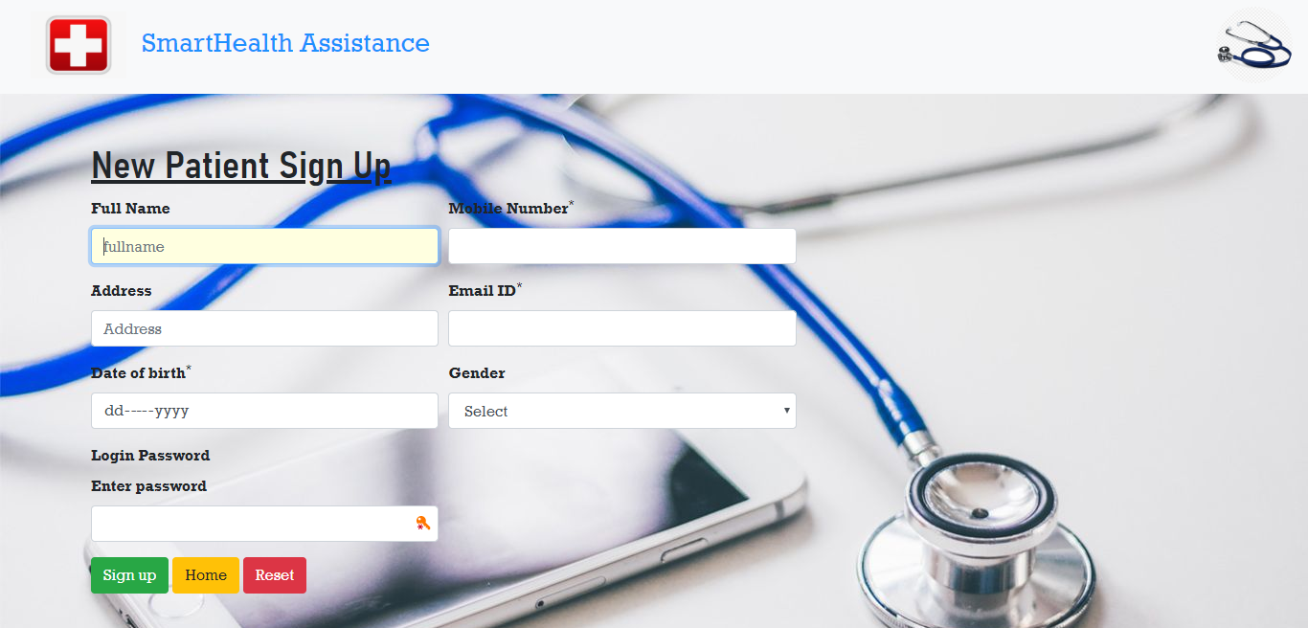

**LOGIN PAGE**

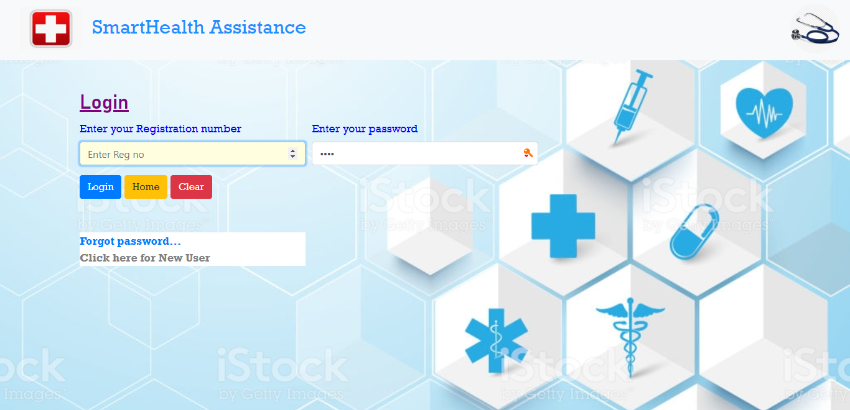

**MEDICINE ENTRY PAGE**

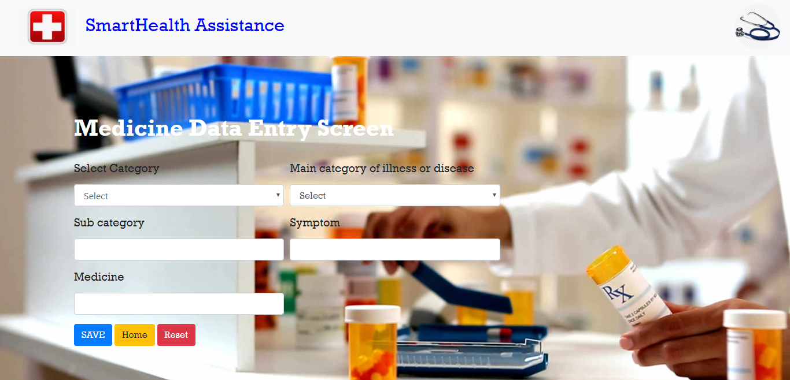

**MAIN CATEGORY PAGE**

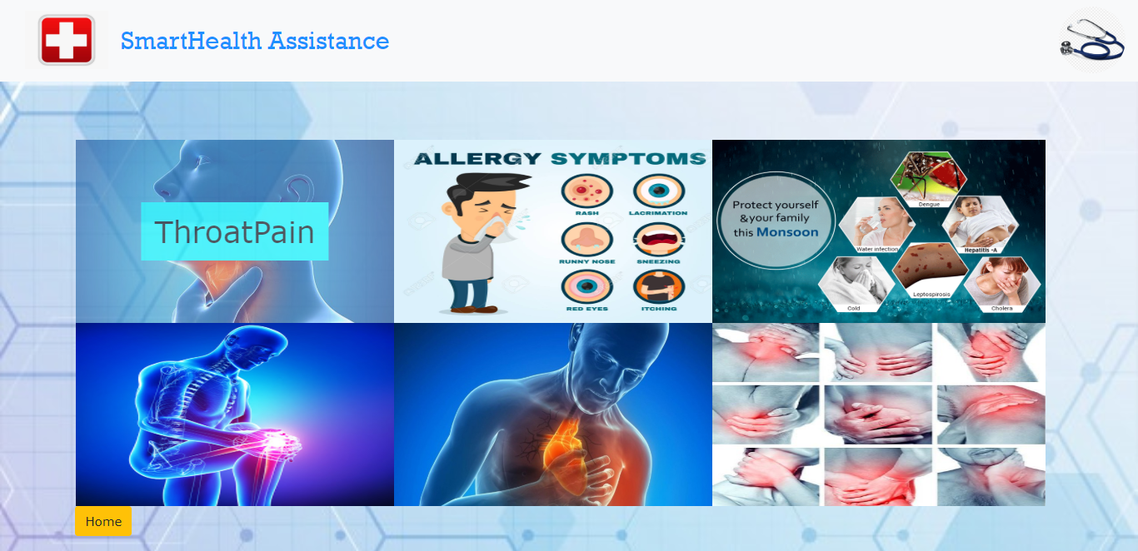

**SUB CATEGORY PAGE**

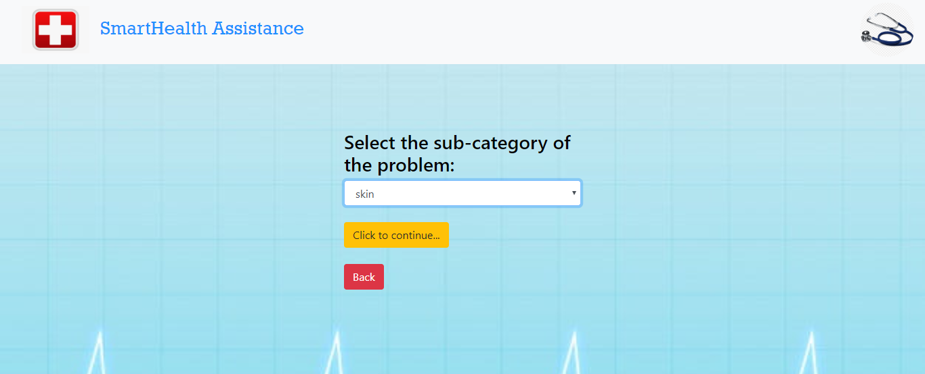

**SYMPTOM PAGE**

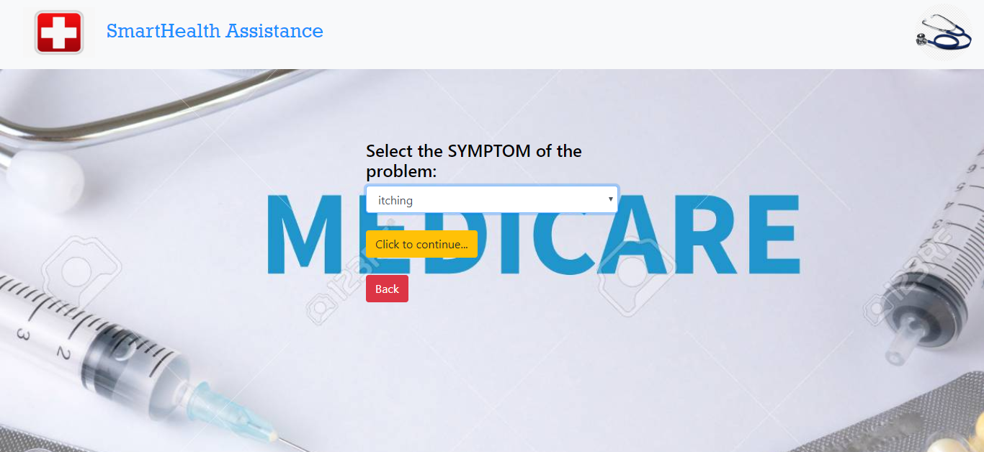

**PRESCRIPTION PAGE**

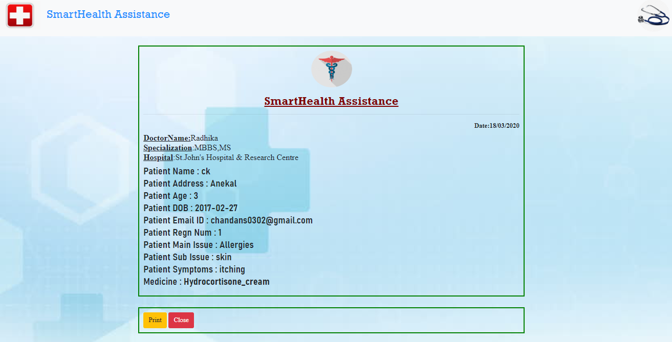

**OTP PAGE**

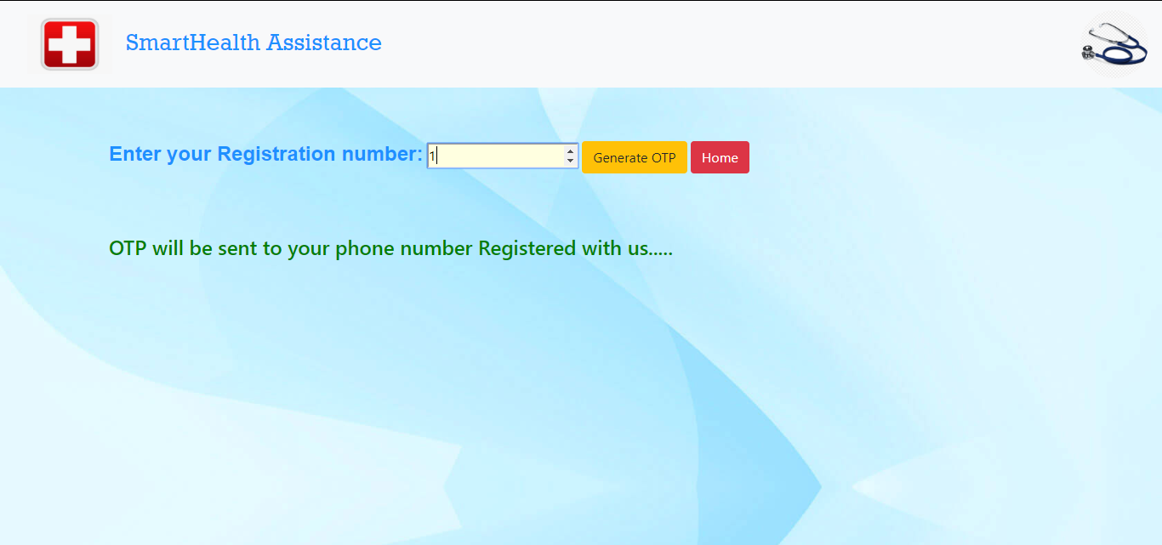

**EMERGENCY PAGE**

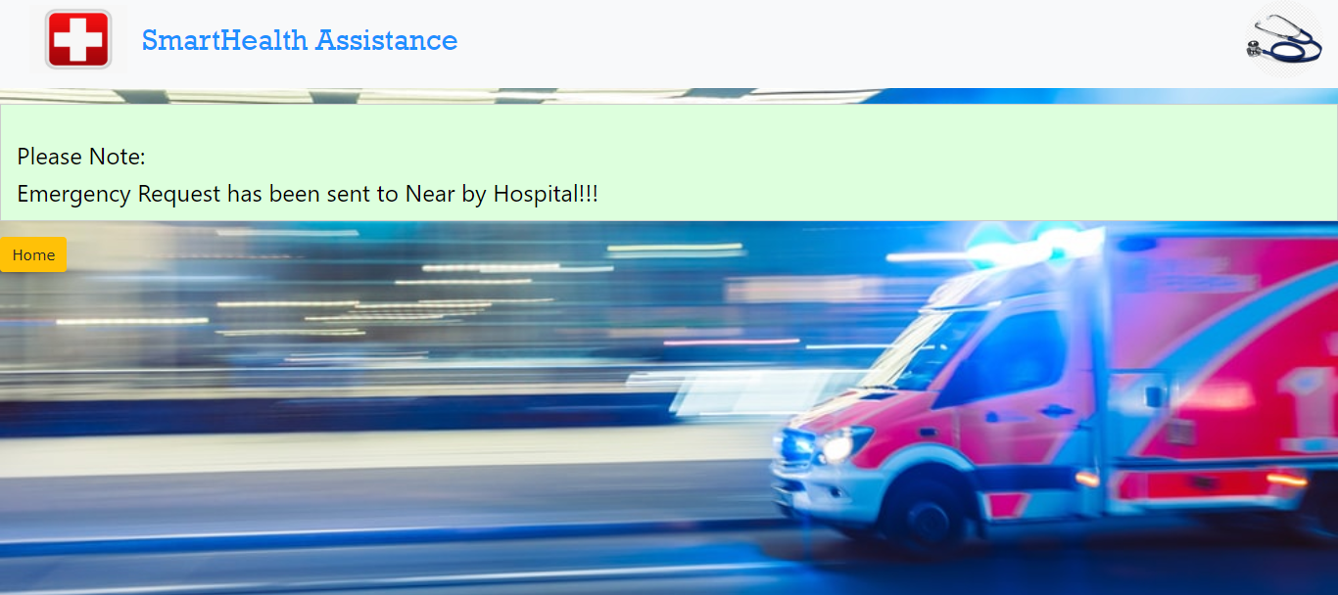

**TESTING**

This phase determines the error in the project. If there is any error, then is must be removed before delivery of the project. For determining errors various types of test actions are performed.

After the Preparation of our project we used it with the help of hypothetical data. As the requirement was satisfied with the data, we implemented the project on the original data.

The system though developed carefully, whenever it is taken in actual use may generate errors. So main purpose of testing is to remove such type of runtime error and correct them. The Scope of system test includes both manual operations and computerized operations. We performed various tests like program system test, string test etc.

**PROGRAM TESTING**

These are designed to test the logic of program. Under this test individual forms were considered as a program and verification was done by entering hypothetical as well as original data.

**SYSTEM TESTING**:

Software is only one element of larger computer based system. Ultimately software is incorporated with other system elements and series of system integration and validation tests are conducted. Steps taken during software design and testing can greatly improve the probability of successful software integration in the larger system.

These are used to test all programs which together constitute the system, consisted of various forms. All forms are liked with each other perfectly and make our system a perfect one.

**CONCLUSION**

Accessing basic healthcare amenities is a real pain in rural India. One has to travel to a nearby town or city for even minor ailments and health assessments. Many elderly citizens residing in villages have to deal with the ordeal of travelling for health check-ups as existing facilities in rural areas are poor. While technology has the ability to change the status quo of basic healthcare facilities in rural areas, it also has a limitation. While the generation have been drastically growing and thus we should be able to implement or include with some technologies which makes rural India much better.

The project in real time will be maintained by compounder who will be guiding for rurals for operate and thus getting prescriptions. It helps to store the records of patient for future references and maintain the records of every patient without any loss of data. There will be an immediate medical caution which have been included in our system where the system server will be connected to hospital server and immediate action will be taken to control the medical situation and provide an ambulance to the emergency location. Human touch is critical to delivering healthcare, and technology has to play the role of an enable, rather than that of a replacement to doctors or hospitals. It is used in the lifesaving equipment in case of emergency .The main purpose and focus of developing the healthcare application is to help people to maintain their health.

**Future Enhancements:**

The main aim of the project is to enable an easy access to the rural areas and provide a temporary cure with in a remote locations. In the upcoming future the project will implemented in the hardware system and thus this system will be deployed in the remote locations where the scarcity of hospitals is high and thus providing the citizens medical emergency. The future enhancement of the project include to improve the scalability and providing friendly access to the users. The project will be capable of enhancing the medical facilities with including every technologies implemented for the upcoming future.

The system will be ease to reach every individuals in the village including infants can be medicated through this system where the system will be integrated with medicines that have been allocate by the doctor with authorized prescription. Every individual data will be recorded and thus providing secure and safety to the users and cannot be manipulated and we have updated with a real time otp where a code will be sent to your registered number to reset your password. And in villages there might be lack of network issues to avoid this we will be implanting with tower to provide consistent signal without any interruptions. There will be continues power supply whereas the server doesn’t shut down and whenever data lost can be recovered.